**Faculty of Science**

**Department of Mathematics and Computer Science**

**Software Engineering (CMPS 344)**

**Insulin optimization App**

**Student Name:**  **Student ID:**

Abedalrahman Sakr 202002605

Omar Sawwas 202203272

Mojahed Taleb 202302621

Mohamad Karim Abo Hosa 202202539

**May 2023**

**Table of Contents**

**Chapter 1. Introduction** 3

**A.** **Main Project Description** 3

**B.** **Problem Statement** 3

**C.** **Project Goal** 3

**D.** **System and Domain Review** 3

**Chapter 2. Project Plan** 4

**A.** **SDLC Model** 4

**B.** **Project Organization** 4

**C.** **Ethical standards and guidelines** 4

**D.** **Schedule/Timeline** 4

**E.** **Feasibility Study** 5

**Chapter 3. Software Requirement Specification** 7

**A.** **Product Functions** 7

**B.** **User characteristics** 7

**C.** **Non-functional Requirements** 8

**D.** **Domain Requirements** 8

**E.** **Functional Requirements** 9

**Chapter 4. Project Design** 10

**A.** **User Interface Prototype** 10

**B.** **Database Diagram** 12

**C.** **Domain/Class/Object Diagrams** 12

**D.** **Sequence Diagrams** 13

**Chapter 5. Methodology** 13

**A.** **Implementation** 13

**B.** **Testing** 13

**C.** **Maintenance** 13

**Chapter 6. Conclusion and Future Work** 14

# **Chapter 1. Introduction**

## **Main Project Description**

It is hard for diabetic patients to calculate the perfect insulin dosage 3 times a day, thus this project aims to ease this task by recommending dosages based on previous results and machine learning.

## **Problem Statement**

The problem is that it is hard to evaluate how much insulin should be injected for a specific food that the patient has never tried before. Also, it is hard to calculate and keep track of the insulin increase or decrease for specific foods based on glucose levels.

## **Project Goal**

The plan is to build a free app that will:

* Give the users access to a data base of how much insulin they should take on specific food
* The database will update and be more optimized every time the user enters new data.
* Give better and more organized data to the patient’s doctor

We may face limitations at the beginning of the project due to it depending on previous data.

## **System and Domain Review**

The existing systems are on paper and are reviewed by taking doctor appointments, thus this app will greatly help doctors and users communicate about the meals and dosages that are being taken.

# **Chapter 2. Project Plan**

## **SDLC Model**

We will be using the incremental model because our project will be divided into 2 functioning increments:

1. The first increment just gathers data from diabetes users and analyses this data individually and optimizes the best insulin dose to be taken for the user.
2. Second increment that is a version two update will be after gathering some data, will be subjected to public diabetic patients where it will work on analyzing data based on machine learning algorithms to give recommendations for other patients for the best insultation for insulin dosage.
3. Each increment by itself will depend on the waterfall model that ensures the full functionality of it from the phase of analysis till the testing phase and this is our case.

Our project should ensure fast release to help diabetes patients take benefit from our service.

## **Project Organization**

Mohammad Karim Abo Hosa: connections with diabetes doctors, developer.

Mojahed Taleb: managing the timeline and features of the project, developer.

Omar Sawwas: connecting with health authorities, developer.

Abedalrahman Sakr: running ads to increase app usage, developer.

## **Ethical standards and guidelines**

The app should be as accurate as possible and based on sound medical research. The app should inform the user of the purpose, functionality and risks of the app and the user should always keep up with his/her doctor to confirm that the app is working as it is supposed to.

## **Schedule/Timeline**

The beta release will be within 6 months.

The program will have 2 iterations: with 1 year for each iteration.

## **Feasibility Study**

**Risk Management**

The app recommending a wrong dosage is a significant risk thus we must design the app to minimize the risk of errors. We will achieve that by using as many data as possible and machine learning.

Another risk is the small spread of the app between diabetic people. We will ask doctors to recommend the apps to their patients (they could get discounts or free trials).

The app should be certified for diabetic people so that our app would be legal to use in as many countries as possible. Thus, we would talk to health authorities and apply for the app to be certified.//

**Technical Feasibility**

computers: our own personal computers

software: react native

developers: our team of 4 people

**Economic Feasibility**

Our app should have returned money benefits thus the app will have users above the age of 22 choose between payment options:

-1. 1$ per month subscription

-2. 80$ for life-time access

|  |  |  |  |  |  |  |
| --- | --- | --- | --- | --- | --- | --- |
| Year | Number of Users | Number of Add Views on a year | Cost $ | Cumulative Costs $ | Benefits | Cumulative benefit |
| 0 | 0 | 0 | $19,600.00 | $19,600.00 | $0.00 | $0.00 |
| 1 | 1500 | 1642500 | $4,020.00 | $23,620.00 | $7,300.00 | $7,300.00 |
| 2 | 5000 | 5475000 | $15,400.00 | $39,020.00 | $29,200.00 | $36,500.00 |
| 3 | 9000 | 9855000 | $3,900.00 | $42,920.00 | $58,400.00 | $94,900.00 |
| 4 | 13000 | 14235000 | $4,000.00 | $46,920.00 | $87,600.00 | $182,500.00 |
| 5 | 17000 | 18615000 | $4,000.00 | $50,920.00 | $116,800.00 | $299,300.00 |

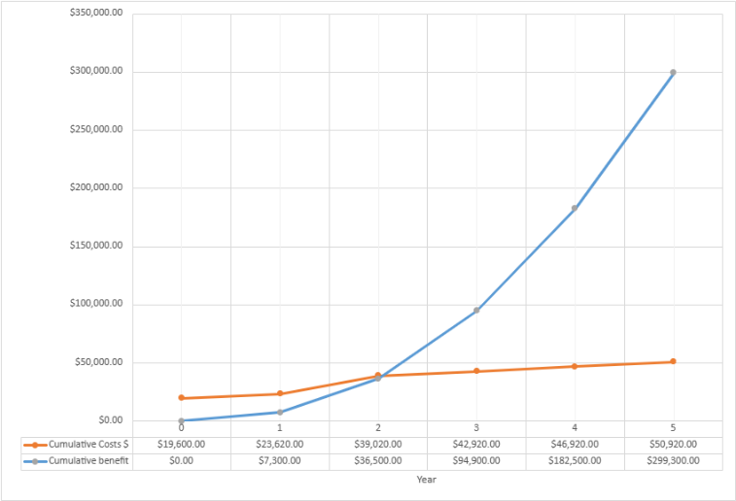

|  |  |  |  |  |  |  |  |  |  |  |  |  |  |
| --- | --- | --- | --- | --- | --- | --- | --- | --- | --- | --- | --- | --- | --- |
| **Year** | Year 0 | | Year 1 | | Year 2 | | | Year 3 | | Year 4 | | Year 5 | |
| **Division** | half 1 | half 2 | half 1 | half 2 | | half 1 | half 2 | half 1 | half 2 | half 1 | half 2 | half 1 | half 2 |
| **Costs** | | | | | | | | | | | | | |
| Development | $3,500.00 | $2,500.00 | $1,000.00 | $500.00 | | $6,000.00 | $4,000.00 | $1,200.00 | $1,200.00 | $1,200.00 | $1,200.00 | $1,200.00 | $1,200.00 |
| Transportation Fee | $800.00 | $800.00 | $0.00 | $0.00 | | $1,000.00 | $1,500.00 | $0.00 | $0.00 | $0.00 | $0.00 | $0.00 | $0.00 |
| Laptops & Mobile Cost | $4,500.00 | $1,500.00 | $0.00 | $0.00 | | $0.00 | $0.00 | $0.00 | $0.00 | $0.00 | $0.00 | $0.00 | $0.00 |
| Server rental | $0.00 | $0.00 | $60.00 | $60.00 | | $100.00 | $100.00 | $150.00 | $150.00 | $200.00 | $200.00 | $200.00 | $200.00 |
| Office rental | $2,400.00 | $2,400.00 | $1,200.00 | $0.00 | | $1,000.00 | $500.00 | $0.00 | $0.00 | $0.00 | $0.00 | $0.00 | $0.00 |
| Maintenance | $600.00 | $600.00 | $600.00 | $600.00 | | $600.00 | $600.00 | $600.00 | $600.00 | $600.00 | $600.00 | $600.00 | $600.00 |
| **Totals** | | | | | | | | | | | | | |
| **Number of User** | $0.00 | $0.00 | $500.00 | $1,500.00 | | $3,000.00 | $5,000.00 | $7,000.00 | $9,000.00 | $11,000.00 | $13,000.00 | $15,000.00 | $17,000.00 |
| **Total Cost** | $11,800.00 | $7,800.00 | $2,860.00 | $1,160.00 | | $8,700.00 | $6,700.00 | $1,950.00 | $1,950.00 | $2,000.00 | $2,000.00 | $2,000.00 | $2,000.00 |
| **Revenue** | $0.00 | $0.00 | $1,825.00 | $5,475.00 | | $10,950.00 | $18,250.00 | $25,550.00 | $32,850.00 | $40,150.00 | $47,450.00 | $54,750.00 | $62,050.00 |
| **Cash Flow** | -$11,800.00 | -$7,800.00 | -$1,035.00 | $4,315.00 | | $2,250.00 | $11,550.00 | $23,600.00 | $30,900.00 | $38,150.00 | $45,450.00 | $52,750.00 | $60,050.00 |
| **Cumulative Cash Flow** | -$11,800.00 | -$19,600.00 | -$20,635.00 | -$16,320.00 | | -$14,070.00 | -$2,520.00 | $21,080.00 | $51,980.00 | $90,130.00 | $135,580.00 | $188,330.00 | $248,380.00 |

Therefore, the project starts making profit at the start of year 3.

**Delivery**

There will be an in-app help section to help anyone who uses our app to be familiar with it.

# **Chapter 3. Software Requirement Specification**

## **Product Functions**

* 1. Take input from users about meals taken. (High)
  2. Take input from users about blood sugar levels before a meal, after a meal, after wakeup, and before sleep. (High)
  3. Take input from users about the amount of insulin used at a certain time. (High)
  4. Give users recommendation about insulin dosage to be taken based on meals taken before and blood sugar level of the user currently. (High)
  5. Let the users create an account using the user signup page. (High)
  6. Let the doctors create a doctors’ account by using the doctor signup page. (High)
  7. Let the user choose his doctor from the list of signed up doctors on the app. (High)
  8. If a doctor is chosen by a user, they could track the blood sugar levels and the amount of insulin taken by the user. (High)
  9. A user would be able to share or not share his meals information with the doctor, to insure the users’ privacy. (High)
  10. The app could remind the user via notifications to take insulin and report taken meals if the user forgets. (Low)
  11. The app would have a function to allow restaurants to give discounts to users of our app. (Low)
  12. The app would have pre entered meals from restaurants that are cooperating with our app. (Med)

## **User characteristics**

Every user has a dashboard that gives him access to graphs of their blood sugar level over time.

Their phone number and contact number.

In addition, only diabetics can make a user account in our application (pending activation).

## **Non-functional Requirements**

Sign contracts with restaurants ready to form partnerships to provide discounts for diabetic users after filling in their information about their meal.

The first version of the app should be finished within a year, and then it should be released.

The user should find the app easy to use as s/he will be using it daily, several times.

## **Domain Requirements**

Getting supervised by doctors and dietitians to ensure the safe use of our application.

The app should be usable on all smart phones. (iOS/Android/Huawei)

Get verification from health authorities to make sure the app is safe to use for patients.

## **Functional Requirements**

Use Case Diagram:

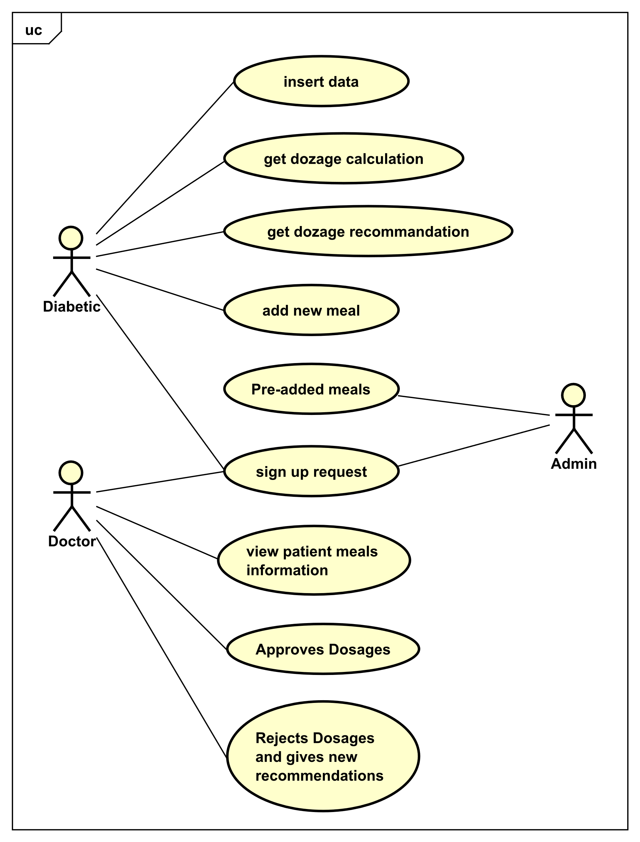

There are multiple use cases for our app:

1. Adding new meals eaten: It involves signing up or logging in (first time opening the app), then adding the new meal through the add meal page.
2. Seeing Recommendations: After the user inputs the meal, he will be asked to input his current blood sugar levels, after that the app will give a recommended dosage.
3. Doctor Supervision: The doctor could supervise the recommended dosage of the patient and send an approval or rejection as he sees fit.
4. Restaurant meals: The app will have pre-added meals and the user can choose them when he eats them, they could be from restaurants or other pre-added meals.
5. Recommendation improvements: The app will use machine learning to give better recommendations to each user based on their previous inputs and approvals from the doctor, and with that the app will understand diverse types of meals and their dosage with time, giving users better results.

# **Chapter 4. Project Design**

## **User Interface Prototype**

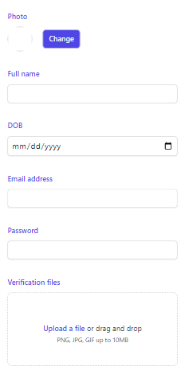 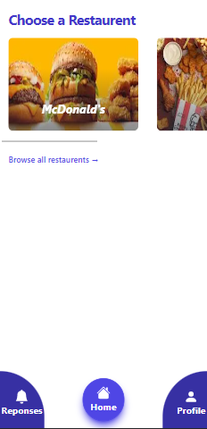

Signup Page Home Page

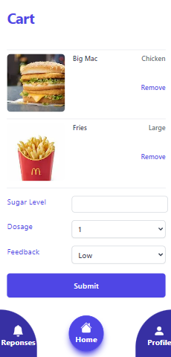 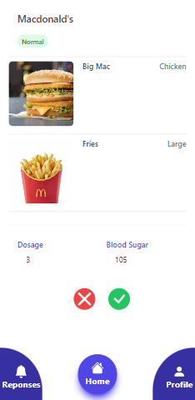

Add Meal Page Doctor Supervision Page

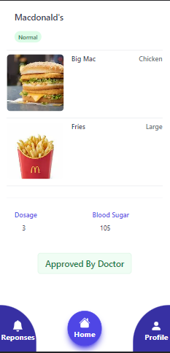 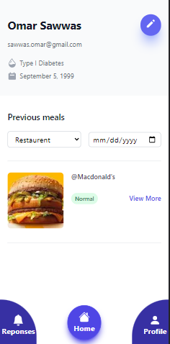

Approved Page Profile Page Sign in Page

## **Database Diagram**

There will be about 5 main database tables: for the doctors, users, restaurants, previously specified food (like restaurant food), and other food (input from users).

## **Domain/Class/Object Diagrams**

and data flow diagram.

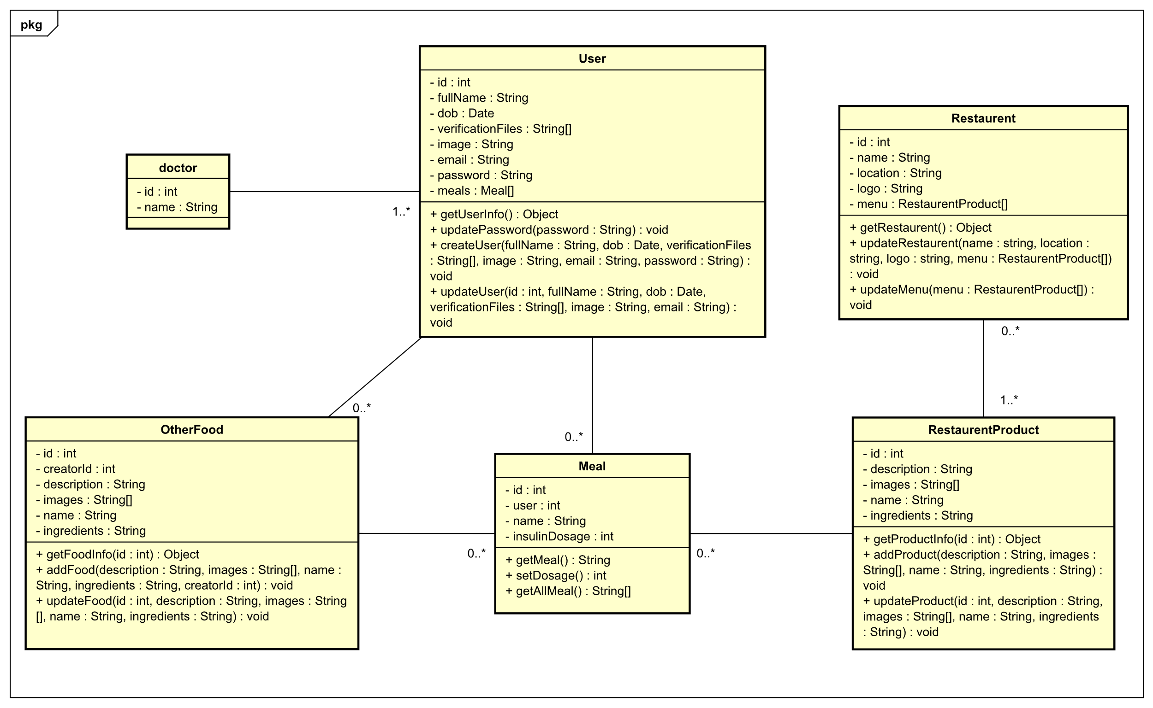

## **Sequence Diagrams**

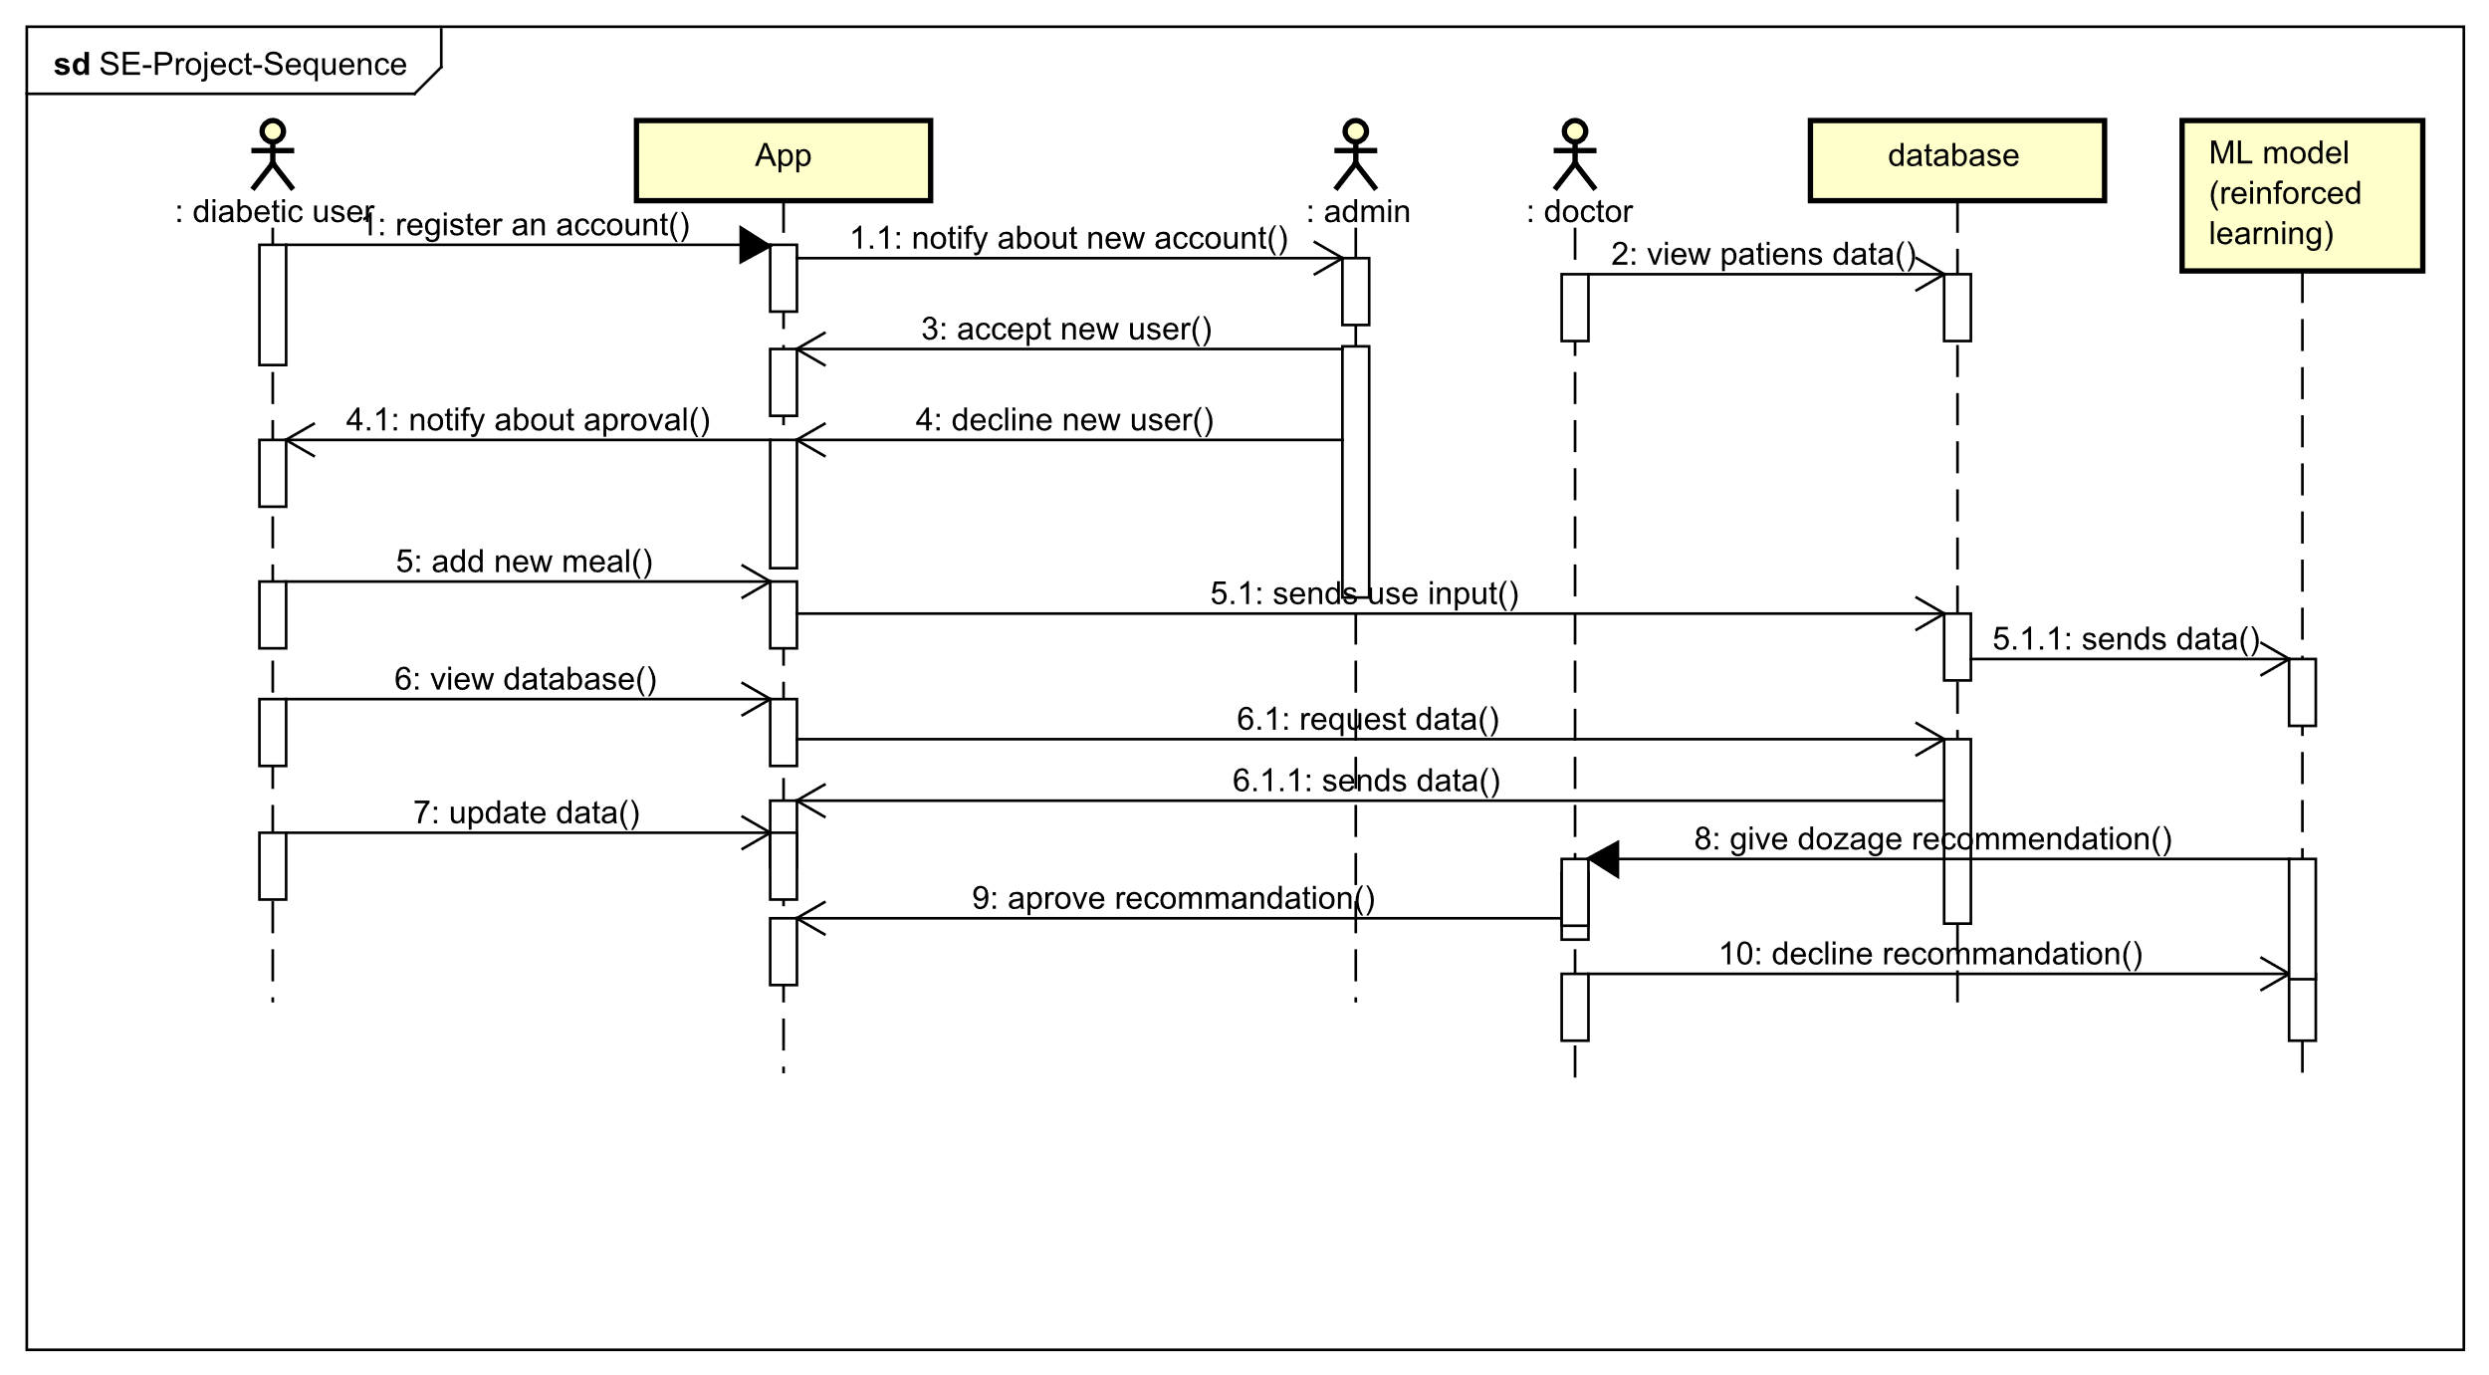

# **Chapter 5. Methodology**

## **Implementation**

We are going to use these software components/programs while developing our app:

React native: Since it will allow us to publish our app on multiple platforms at the same time.

And other software components like: mongo DB, express JS and graphQL.

## **Testing**

Debugging tools like logging information on the counsel.

Type script.

Beta version to general users.

## **Maintenance**

GitHub

Application will be done in multiple modules to make maintenance easier.

# **Chapter 6. Conclusion and Future Work**

Overall, this app will greatly help diabetic patients with their daily lives as the dosage for insulin injections is an important thing for them to stay healthy, and not have any other complications from over or lower dosage injections. In the future we would like to see our app help as many patients as possible and we would like to work with the government to make this app on every diabetic person’s phone to help them with their daily lives.